**AA300**

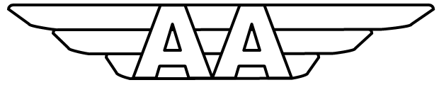

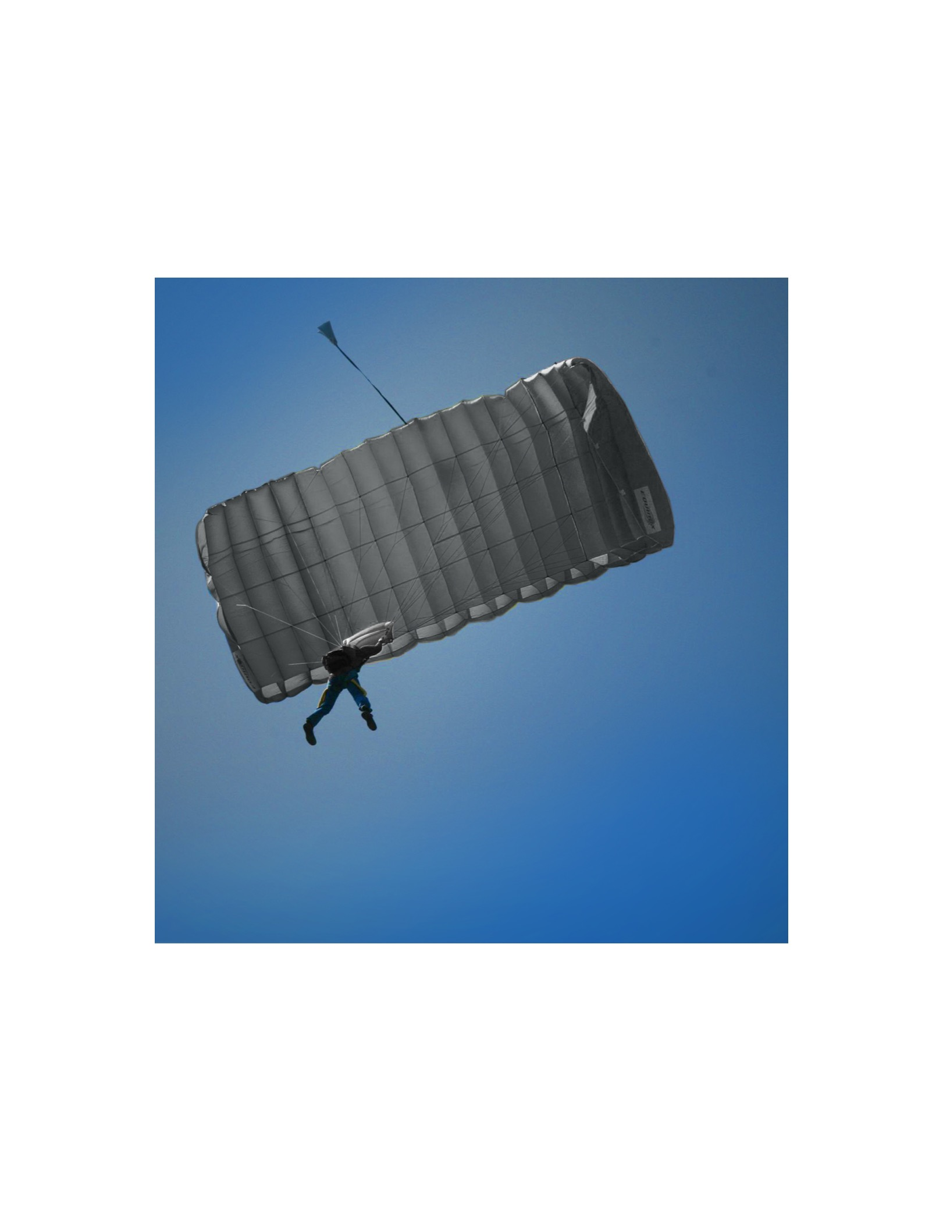

|  |  |
| --- | --- |
| **PRODUCT**  **DESCRIPTION** | **AA300**  **300/270 TACTICAL TRAINING SYSTEM** |
| **MAXIMUM ALTITUDE**  **MAX DEPLOYMENT SPEED**  **MAX EXIT WEIGHT**  **CANOPY** | **25,000 FEET**  **150 KIAS**  **145KG 319LBS**  **9 CELL HYBRID CONSTRUCTION** |
| **AREA**  **SPAN**  **CORD** | **MAIN 300 RES 270**  **MAIN 27.41 RES 24.1**  **MAIN 10.91 RES 11.5** |
| **ASPECT RATIO**  **NUMBER OF CELLS**  **VOLUME** | **MAIN 2.6 RES 2.1**  **MAIN 9 RES 7**  **MAIN 652 ci**  **RES 604ci** |
| **FABRIC**  **SUSPENSION LINES**  **GLIDE RATIO**  **GENERAL** | **TOP SKIN ZP 0 CFM RIBS AND BOTTOM SKIN NANO 0-3 CFM**  **600LB DACRON**  **3.5:1**  **FREEFALL PARACHUTE SYSTEM DEVELOPED FOR TRAINING TACTICAL TEAMS**  **CONFIGURABLE FOR AFF, STATIC LINE, AND FREEFALL OPERATIONS**  **ADJUSTABLE HARNESS IS COMPATIBLE WITH ALL MODERN AAD’S, RIG INCLUDES MAGNETIC RISER COVERS AND CAN BE FITTED WITH A MARD** |
|  |  |
|  |  |
|  |  |

**TACTICAL PARACHUTE SYSTEM**

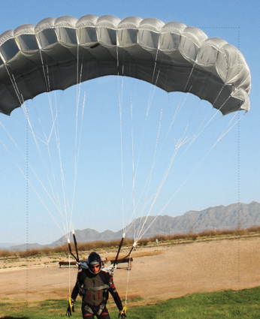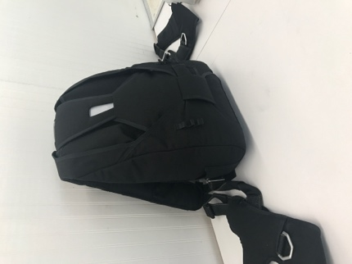

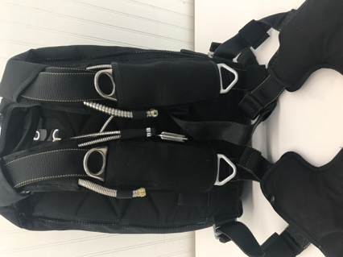

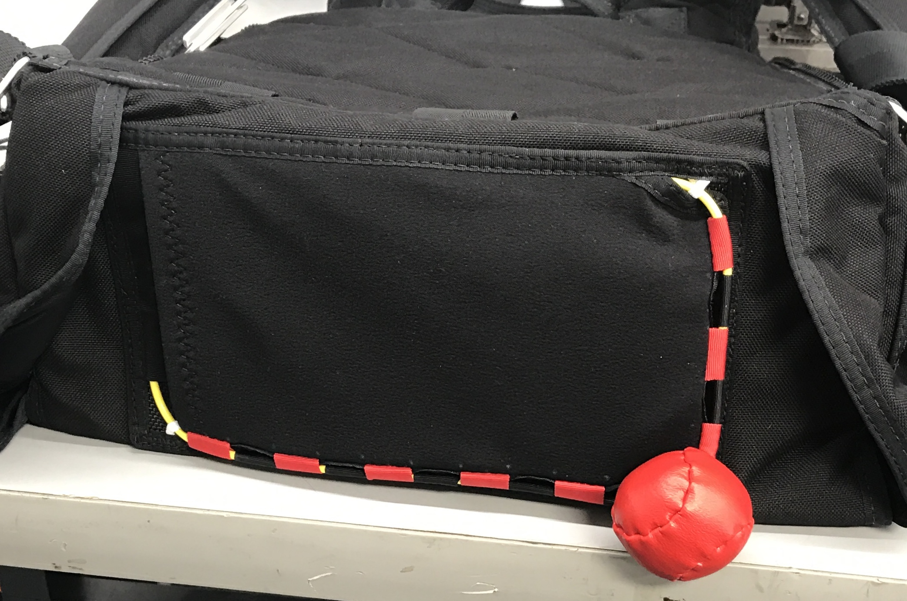

**Aero Aviation, LLC**

**332 West Minnesota Ave**

**DeLand, FL 32720 USA**